C - Verificación de condiciones de bloqueo del monedero

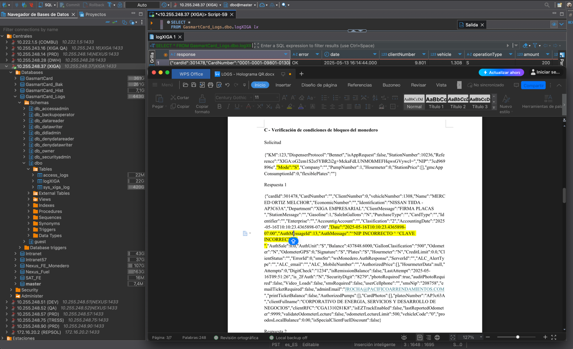
PLACASo
Saldo autorizado y tipo de carga
Código y mensaje
Identificador del Vehículo
Nombre del Usuario
Nip Encriptado
Referencia Encriptada

Solicitud

{"KM":123,"DispenserProtocol":"Bennet","isAppRequest":false,"StationNumber":10236,"Reference":"XIGA:oG2em1S2o5YBR2i2g+MckaFdLUNMOhMEFHqwsGVywcI=","NIP":"3cd969896e","Mode":"S","Company":"","PumpNumber":1,"Hourmeter":0,"StationPrice":[],"gmcAppConsumptionId":0,"flexiblePlates":""}
Respuesta 1
{"cardId":301478,"CardNumber":"","ClientNumber":0,"vehicleNumber":1308,"Name":"MERCED ORTIZ MELCHOR","EconomicNumber":"","Identification":"NISSAN TIIDA -AP3C63A","Department":"XIGA EMPRESARIAL","ClientMessage":"FIRMA PLACAS ","StationMessage":"","Gasoline":1,"SaleInGallons":"N","PurchaseType":"","CardType":"","Identifier":"","Enterprise":"","AccountigAccount":"","Clasification":"2","AccountingDate":"2025-05-16T10:10:23.4365898-07:00","Date":"2025-05-16T10:10:23.4365898-07:00","AuthMessageId":13,"AuthMessage":"^NIP INCORRECTO ^ ^CLAVE INCORRECTA^ ","AuthSale":0.0,"AuthUnit":"$","Balance":437848.6000,"GallonClasification":"500","Odometer":"N","OdometerGPS":0,"Signature":"S","Plates":"S","Hourmeter":"N","CreditLimit":0.0,"ClientStatus":"","ErrorId":0,"smsStr":"wsMonedero.AuthResponse","ServerId":"","ALC_AlertType":"","ALC_email":"","ALC_MobileNumber":"","AuthorizedPrice":[],"HourmeterData":null,"Attempts":0,"DigitCheck":"1234","isRemissionBalance":false,"LastAttempt":"2025-05-16T09:51:26","is_2FAuth":"N","SecurityDigit":"8279","photoRequired":true,"auditPhotoRequired":false,"Video_Loads":false,"smsRequired":false,"userCellphone":"","smsNip":"208758","emailTicketRequired":false,"adminEmail":"JROCHA@PACIFICOARRENDAMIENTOS.COM","printTicketBalance":false,"AuthorizedPumps":[],"CardPhotos":[],"platesNumber":"AP3c63A","clientFullname":"CORPORATIVO DE ENERGIA, SERVICIOS Y DESARROLLO DE NEGOCIOS","clientRFC":"CGA1310281K8","isEZTrackEnabled":false,"lastReportedOdometer":9999,"validateOdometerLecture":false,"odometerLectureLimit":500,"vehicleCode":"0","proodosLocalBalance":0.00,"isSpecialClientFuelDiscount":false}

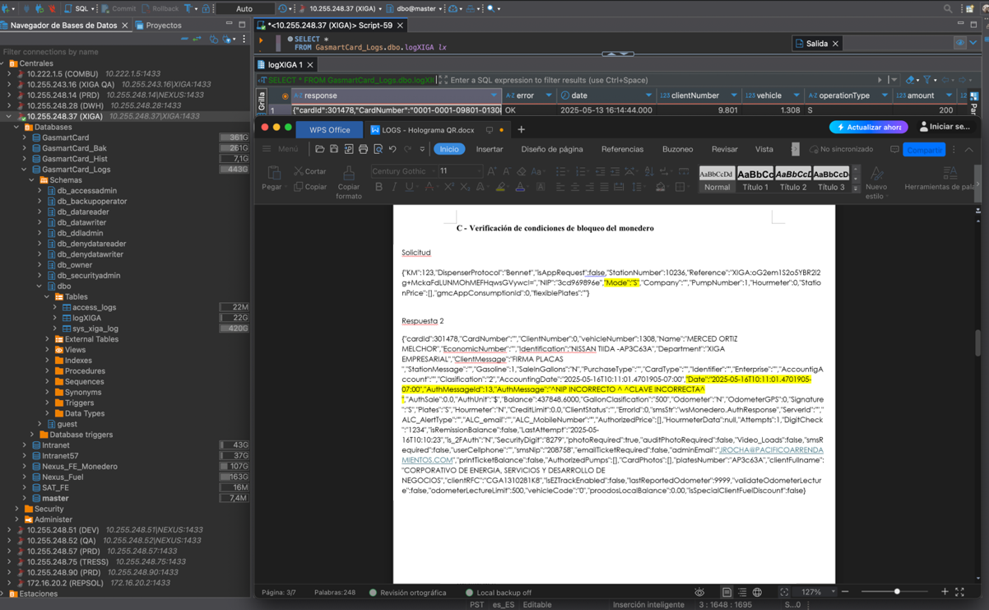
PLACAS
Saldo autorizado y tipo de carga
Código y mensaje
Identificador del vehículo
Nombre del usuario
Referencia Encriptada
Nip Encriptado

Solicitud

{"KM":123,"DispenserProtocol":"Bennet","isAppRequest":false,"StationNumber":10236,"Reference":"XIGA:oG2em1S2o5YBR2i2g+MckaFdLUNMOhMEFHqwsGVywcI=","NIP":"3cd969896e","Mode":"S","Company":"","PumpNumber":1,"Hourmeter":0,"StationPrice":[],"gmcAppConsumptionId":0,"flexiblePlates":""}

Respuesta 2
{"cardId":301478,"CardNumber":"","ClientNumber":0,"vehicleNumber":1308,"Name":"MERCED ORTIZ MELCHOR","EconomicNumber":"","Identification":"NISSAN TIIDA -AP3C63A","Department":"XIGA EMPRESARIAL","ClientMessage":"FIRMA PLACAS ","StationMessage":"","Gasoline":1,"SaleInGallons":"N","PurchaseType":"","CardType":"","Identifier":"","Enterprise":"","AccountigAccount":"","Clasification":"2","AccountingDate":"2025-05-16T10:11:01.4701905-07:00","Date":"2025-05-16T10:11:01.4701905-07:00","AuthMessageId":13,"AuthMessage":"^NIP INCORRECTO ^ ^CLAVE INCORRECTA^ ","AuthSale":0.0,"AuthUnit":"$","Balance":437848.6000,"GallonClasification":"500","Odometer":"N","OdometerGPS":0,"Signature":"S","Plates":"S","Hourmeter":"N","CreditLimit":0.0,"ClientStatus":"","ErrorId":0,"smsStr":"wsMonedero.AuthResponse","ServerId":"","ALC_AlertType":"","ALC_email":"","ALC_MobileNumber":"","AuthorizedPrice":[],"HourmeterData":null,"Attempts":1,"DigitCheck":"1234","isRemissionBalance":false,"LastAttempt":"2025-05-16T10:10:23","is_2FAuth":"N","SecurityDigit":"8279","photoRequired":true,"auditPhotoRequired":false,"Video_Loads":false,"smsRequired":false,"userCellphone":"","smsNip":"208758","emailTicketRequired":false,"adminEmail":"JROCHA@PACIFICOARRENDAMIENTOS.COM","printTicketBalance":false,"AuthorizedPumps":[],"CardPhotos":[],"platesNumber":"AP3c63A","clientFullname":"CORPORATIVO DE ENERGIA, SERVICIOS Y DESARROLLO DE NEGOCIOS","clientRFC":"CGA1310281K8","isEZTrackEnabled":false,"lastReportedOdometer":9999,"validateOdometerLecture":false,"odometerLectureLimit":500,"vehicleCode":"0","proodosLocalBalance":0.00,"isSpecialClientFuelDiscount":false}

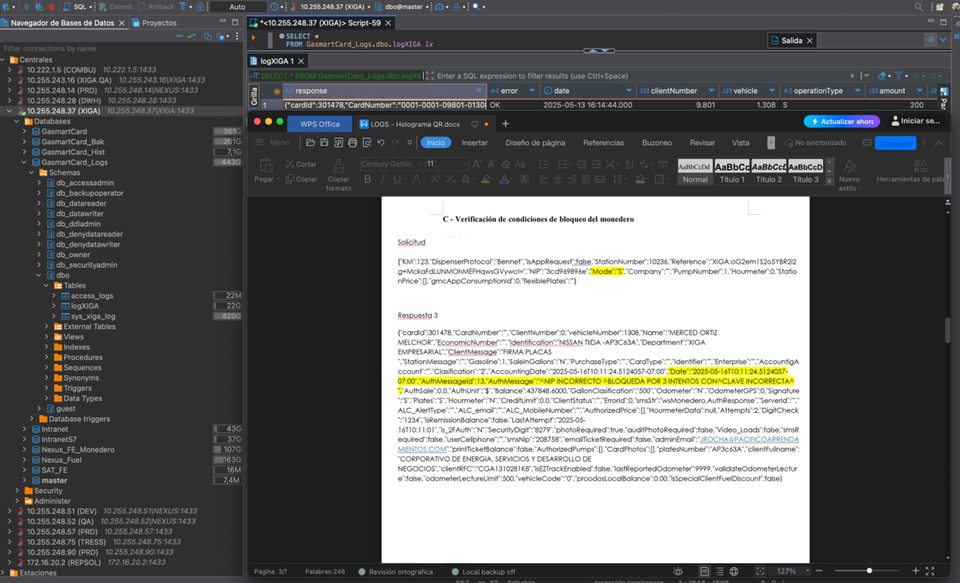
PLACAS
Saldo autorizado y tipo de carga
Código y mensaje
Identificador del Vehículo
Nombre del Usuario
Nip Encriptado
Referencia Encriptada

Solicitud

{"KM":123,"DispenserProtocol":"Bennet","isAppRequest":false,"StationNumber":10236,"Reference":"XIGA:oG2em1S2o5YBR2i2g+MckaFdLUNMOhMEFHqwsGVywcI=","NIP":"3cd969896e","Mode":"S","Company":"","PumpNumber":1,"Hourmeter":0,"StationPrice":[],"gmcAppConsumptionId":0,"flexiblePlates":""}

Respuesta 3
{"cardId":301478,"CardNumber":"","ClientNumber":0,"vehicleNumber":1308,"Name":"MERCED ORTIZ MELCHOR","EconomicNumber":"","Identification":"NISSAN TIIDA -AP3C63A","Department":"XIGA EMPRESARIAL","ClientMessage":"FIRMA PLACAS ","StationMessage":"","Gasoline":1,"SaleInGallons":"N","PurchaseType":"","CardType":"","Identifier":"","Enterprise":"","AccountigAccount":"","Clasification":"2","AccountingDate":"2025-05-16T10:11:24.5124057-07:00","Date":"2025-05-16T10:11:24.5124057-07:00","AuthMessageId":13,"AuthMessage":"^NIP INCORRECTO ^BLOQUEDA POR 3 INTENTOS CON^CLAVE INCORRECTA^ ","AuthSale":0.0,"AuthUnit":"$","Balance":437848.6000,"GallonClasification":"500","Odometer":"N","OdometerGPS":0,"Signature":"S","Plates":"S","Hourmeter":"N","CreditLimit":0.0,"ClientStatus":"","ErrorId":0,"smsStr":"wsMonedero.AuthResponse","ServerId":"","ALC_AlertType":"","ALC_email":"","ALC_MobileNumber":"","AuthorizedPrice":[],"HourmeterData":null,"Attempts":2,"DigitCheck":"1234","isRemissionBalance":false,"LastAttempt":"2025-05-16T10:11:01","is_2FAuth":"N","SecurityDigit":"8279","photoRequired":true,"auditPhotoRequired":false,"Video_Loads":false,"smsRequired":false,"userCellphone":"","smsNip":"208758","emailTicketRequired":false,"adminEmail":"JROCHA@PACIFICOARRENDAMIENTOS.COM","printTicketBalance":false,"AuthorizedPumps":[],"CardPhotos":[],"platesNumber":"AP3c63A","clientFullname":"CORPORATIVO DE ENERGIA, SERVICIOS Y DESARROLLO DE NEGOCIOS","clientRFC":"CGA1310281K8","isEZTrackEnabled":false,"lastReportedOdometer":9999,"validateOdometerLecture":false,"odometerLectureLimit":500,"vehicleCode":"0","proodosLocalBalance":0.00,"isSpecialClientFuelDiscount":false}

