C - Verificación de condiciones de bloqueo del monedero
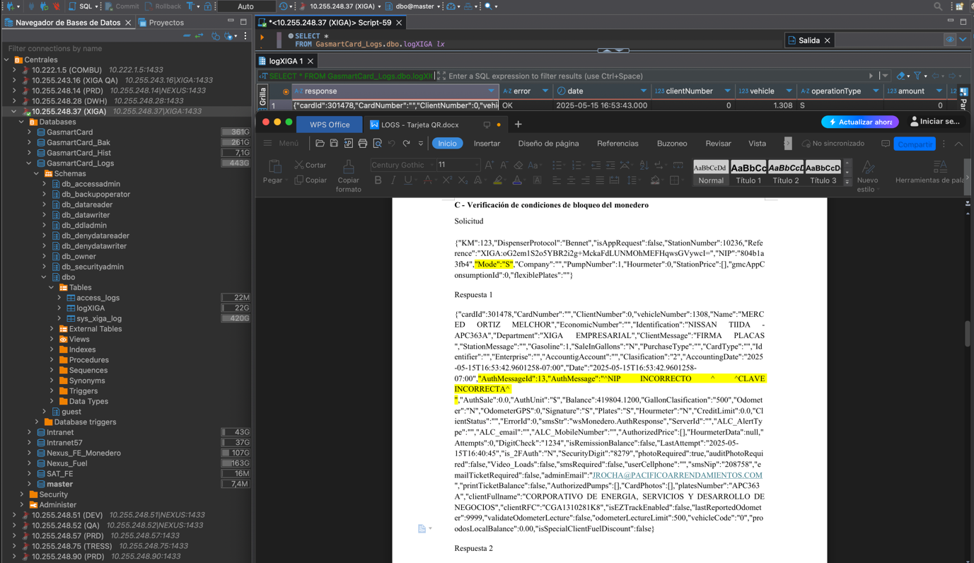
Nombre del Usuario
PLACAS
Saldo autorizado y tipo de carga
Nip Encriptado
Código y mensaje
Identificador del Vehículo
Referencia Encriptada

Solicitud

{"KM":123,"DispenserProtocol":"Bennet","isAppRequest":false,"StationNumber":10236,"Reference":"XIGA:oG2em1S2o5YBR2i2g+MckaFdLUNMOhMEFHqwsGVywcI=","NIP":"804b1a3fb4","Mode":"S","Company":"","PumpNumber":1,"Hourmeter":0,"StationPrice":[],"gmcAppConsumptionId":0,"flexiblePlates":""}
Respuesta 1
{"cardId":301478,"CardNumber":"","ClientNumber":0,"vehicleNumber":1308,"Name":"MERCED ORTIZ MELCHOR","EconomicNumber":"","Identification":"NISSAN TIIDA -APC363A","Department":"XIGA EMPRESARIAL","ClientMessage":"FIRMA PLACAS ","StationMessage":"","Gasoline":1,"SaleInGallons":"N","PurchaseType":"","CardType":"","Identifier":"","Enterprise":"","AccountigAccount":"","Clasification":"2","AccountingDate":"2025-05-15T16:53:42.9601258-07:00","Date":"2025-05-15T16:53:42.9601258-07:00","AuthMessageId":13,"AuthMessage":"^NIP INCORRECTO ^ ^CLAVE INCORRECTA^ ","AuthSale":0.0,"AuthUnit":"$","Balance":419804.1200,"GallonClasification":"500","Odometer":"N","OdometerGPS":0,"Signature":"S","Plates":"S","Hourmeter":"N","CreditLimit":0.0,"ClientStatus":"","ErrorId":0,"smsStr":"wsMonedero.AuthResponse","ServerId":"","ALC_AlertType":"","ALC_email":"","ALC_MobileNumber":"","AuthorizedPrice":[],"HourmeterData":null,"Attempts":0,"DigitCheck":"1234","isRemissionBalance":false,"LastAttempt":"2025-05-15T16:40:45","is_2FAuth":"N","SecurityDigit":"8279","photoRequired":true,"auditPhotoRequired":false,"Video_Loads":false,"smsRequired":false,"userCellphone":"","smsNip":"208758","emailTicketRequired":false,"adminEmail":"JROCHA@PACIFICOARRENDAMIENTOS.COM","printTicketBalance":false,"AuthorizedPumps":[],"CardPhotos":[],"platesNumber":"APC363A","clientFullname":"CORPORATIVO DE ENERGIA, SERVICIOS Y DESARROLLO DE NEGOCIOS","clientRFC":"CGA1310281K8","isEZTrackEnabled":false,"lastReportedOdometer":9999,"validateOdometerLecture":false,"odometerLectureLimit":500,"vehicleCode":"0","proodosLocalBalance":0.00,"isSpecialClientFuelDiscount":false}

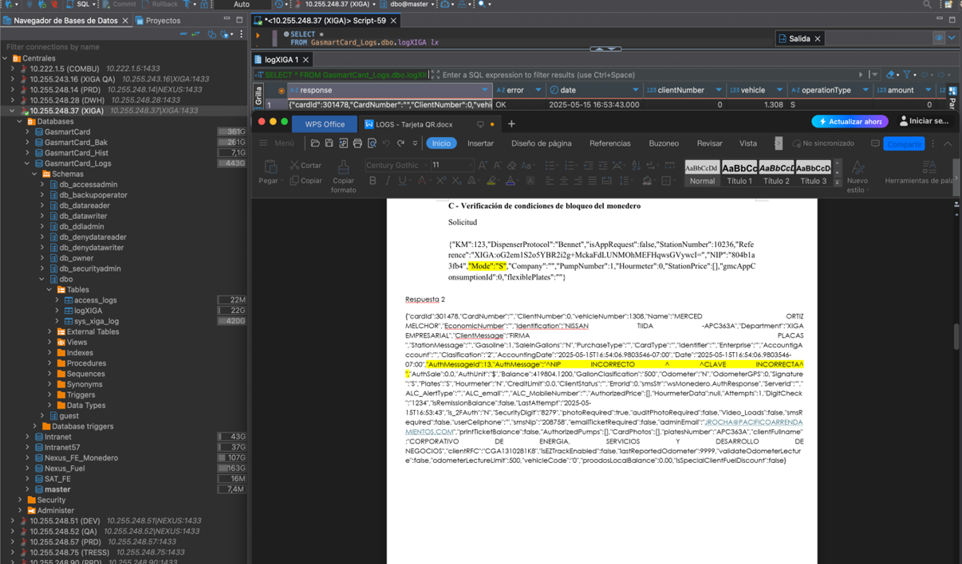
Placas
Saldo autorizado y tipo de carga
Código y mensaje
Identificador del vehículo
Nombre del Usuario
NIP Encriptado
Referencia Encriptada

Solicitud

{"KM":123,"DispenserProtocol":"Bennet","isAppRequest":false,"StationNumber":10236,"Reference":"XIGA:oG2em1S2o5YBR2i2g+MckaFdLUNMOhMEFHqwsGVywcI=","NIP":"804b1a3fb4","Mode":"S","Company":"","PumpNumber":1,"Hourmeter":0,"StationPrice":[],"gmcAppConsumptionId":0,"flexiblePlates":""}

Respuesta 2
{"cardId":301478,"CardNumber":"","ClientNumber":0,"vehicleNumber":1308,"Name":"MERCED ORTIZ MELCHOR","EconomicNumber":"","Identification":"NISSAN TIIDA -APC363A","Department":"XIGA EMPRESARIAL","ClientMessage":"FIRMA PLACAS ","StationMessage":"","Gasoline":1,"SaleInGallons":"N","PurchaseType":"","CardType":"","Identifier":"","Enterprise":"","AccountigAccount":"","Clasification":"2","AccountingDate":"2025-05-15T16:54:06.9803546-07:00","Date":"2025-05-15T16:54:06.9803546-07:00","AuthMessageId":13,"AuthMessage":"^NIP INCORRECTO ^ ^CLAVE INCORRECTA^ ","AuthSale":0.0,"AuthUnit":"$","Balance":419804.1200,"GallonClasification":"500","Odometer":"N","OdometerGPS":0,"Signature":"S","Plates":"S","Hourmeter":"N","CreditLimit":0.0,"ClientStatus":"","ErrorId":0,"smsStr":"wsMonedero.AuthResponse","ServerId":"","ALC_AlertType":"","ALC_email":"","ALC_MobileNumber":"","AuthorizedPrice":[],"HourmeterData":null,"Attempts":1,"DigitCheck":"1234","isRemissionBalance":false,"LastAttempt":"2025-05-15T16:53:43","is_2FAuth":"N","SecurityDigit":"8279","photoRequired":true,"auditPhotoRequired":false,"Video_Loads":false,"smsRequired":false,"userCellphone":"","smsNip":"208758","emailTicketRequired":false,"adminEmail":"JROCHA@PACIFICOARRENDAMIENTOS.COM","printTicketBalance":false,"AuthorizedPumps":[],"CardPhotos":[],"platesNumber":"APC363A","clientFullname":"CORPORATIVO DE ENERGIA, SERVICIOS Y DESARROLLO DE NEGOCIOS","clientRFC":"CGA1310281K8","isEZTrackEnabled":false,"lastReportedOdometer":9999,"validateOdometerLecture":false,"odometerLectureLimit":500,"vehicleCode":"0","proodosLocalBalance":0.00,"isSpecialClientFuelDiscount":false}

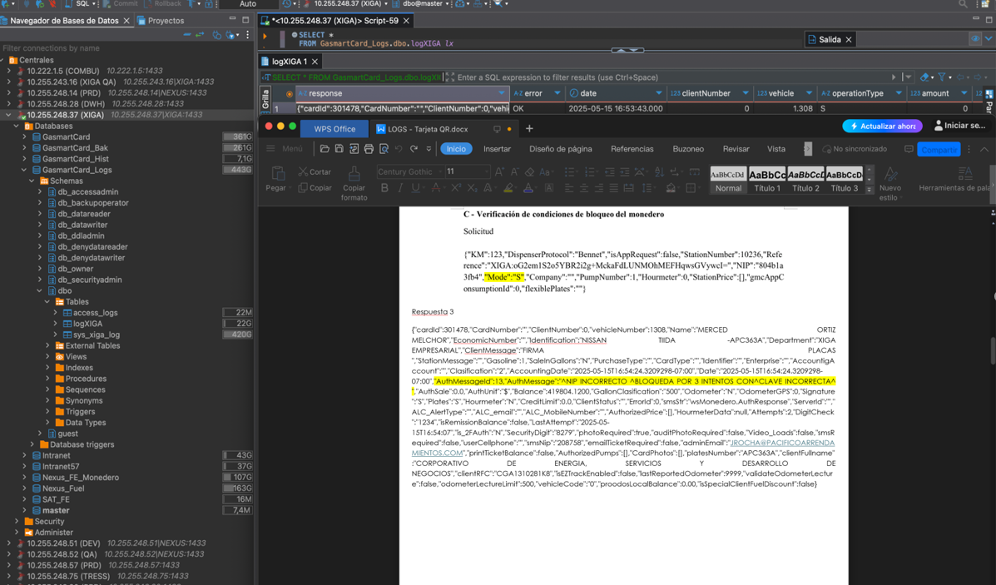
Placas
Saldo Autorizado y Tipo de carga
Código y mensaje
Identificador del Vehículo
Nombre del Usuario
Referencia Encriptada
NIP Encriptado

Solicitud

{"KM":123,"DispenserProtocol":"Bennet","isAppRequest":false,"StationNumber":10236,"Reference":"XIGA:oG2em1S2o5YBR2i2g+MckaFdLUNMOhMEFHqwsGVywcI=","NIP":"804b1a3fb4","Mode":"S","Company":"","PumpNumber":1,"Hourmeter":0,"StationPrice":[],"gmcAppConsumptionId":0,"flexiblePlates":""}

Respuesta 3
{"cardId":301478,"CardNumber":"","ClientNumber":0,"vehicleNumber":1308,"Name":"MERCED ORTIZ MELCHOR","EconomicNumber":"","Identification":"NISSAN TIIDA -APC363A","Department":"XIGA EMPRESARIAL","ClientMessage":"FIRMA PLACAS ","StationMessage":"","Gasoline":1,"SaleInGallons":"N","PurchaseType":"","CardType":"","Identifier":"","Enterprise":"","AccountigAccount":"","Clasification":"2","AccountingDate":"2025-05-15T16:54:24.3209298-07:00","Date":"2025-05-15T16:54:24.3209298-07:00","AuthMessageId":13,"AuthMessage":"^NIP INCORRECTO ^BLOQUEDA POR 3 INTENTOS CON^CLAVE INCORRECTA^ ","AuthSale":0.0,"AuthUnit":"$","Balance":419804.1200,"GallonClasification":"500","Odometer":"N","OdometerGPS":0,"Signature":"S","Plates":"S","Hourmeter":"N","CreditLimit":0.0,"ClientStatus":"","ErrorId":0,"smsStr":"wsMonedero.AuthResponse","ServerId":"","ALC_AlertType":"","ALC_email":"","ALC_MobileNumber":"","AuthorizedPrice":[],"HourmeterData":null,"Attempts":2,"DigitCheck":"1234","isRemissionBalance":false,"LastAttempt":"2025-05-15T16:54:07","is_2FAuth":"N","SecurityDigit":"8279","photoRequired":true,"auditPhotoRequired":false,"Video_Loads":false,"smsRequired":false,"userCellphone":"","smsNip":"208758","emailTicketRequired":false,"adminEmail":"JROCHA@PACIFICOARRENDAMIENTOS.COM","printTicketBalance":false,"AuthorizedPumps":[],"CardPhotos":[],"platesNumber":"APC363A","clientFullname":"CORPORATIVO DE ENERGIA, SERVICIOS Y DESARROLLO DE NEGOCIOS","clientRFC":"CGA1310281K8","isEZTrackEnabled":false,"lastReportedOdometer":9999,"validateOdometerLecture":false,"odometerLectureLimit":500,"vehicleCode":"0","proodosLocalBalance":0.00,"isSpecialClientFuelDiscount":false}

